**MINISTRY OF EDUCATION AND TRAINING**

**FPT UNIVERSITY**

Capstone Project Document

**Laptop Reviews**

|  |  |
| --- | --- |
| **Group 1** | |
| **Group member** | Vo Thi Minh Chau – Team Leader – SE60931  Nguyen Van Hon – Team Member - 60390  Dinh Huu Toan – Team Member - SE60871  Nguyen Manh Khuong – Team Member - 60455 |
| **Supervisor** | Mr. Kieu Trong Khanh |
| **Ext. Supervisor** | N/A |
| **Capstone Project code** | LRA |

-Ho Chi Minh City, ***07/2015***-

*This page is intentionally left blank*

***ACKNOWLEDGEMENTS***

We wish to thank various people for their contribution to this project: Our teachers for their advice and participation in the final review, our friends for their valuable technical support.

Special thanks should be given to Mr.Kiều Trọng Khánh, our research supervisor for his professional guidance and the useful, constructive recommendations throughout the course of this project.

# Table of Contents

Table of Contents 4

List of Tables 5

List of Figures 6

Definitions, Acronyms, and Abbreviations 7

Report No.5 System Implementation & Test 8

**1.** **Introduction** 8

1.1 System Overview 8

1.2 Test Approach 8

2. Database Relationship Diagram 8

2.1 Diagram 8

2.2 Data Dictionary 10

3. Performance Measures 14

3.1 Parser Performance 14

3.2 Analyzing Comment Algorithm Performance 14

4. Test Plan 14

4.1 Features to be tested 14

4.2 Features not to be tested 14

5. System Testing Test Case 15

5.1 Guest Test Case 16

5.2 Staff Test Case 17

# List of Tables

Table 1 Data Dictionary 10

Table 3: Attribute Data Dictionary 14

Table 4: Search Product by name Test Case 16

Table 5: Report Comment Test Case 16

Table 6: View Detail Test Case 17

Table 7: Manage Parser Test Case 18

Table 8: Create New Site Test Case 19

# List of Figures

Figure 1 Database Relationship Diagram 9

Figure 2 Guest, Staff Core Flow 15

# Definitions, Acronyms, and Abbreviations

|  |  |
| --- | --- |
| LRA | Laptop Review |

# Report No.5 System Implementation & Test

1. **Introduction**

### System Overview

This section provides in detail all necessary information about test plans, test cases, test result, test environments, pass/fail criteria and risks estimations as well as a checklist to cover all possible cases of LRA.

### Test Approach

- Goal: To test the whole system based on the core workflow.

- Method: System Testing, Black-box Testing.

## Database Relationship Diagram

### Diagram



Figure 1 Database Relationship Diagram

### Data Dictionary

|  |  |
| --- | --- |
| **Entity Data dictionary: describe content of all entities** | |
| **Entity Name** | **Description** |
| Account | Describe all accounts in the system. Account includes: admin and staff. |
| AliasProduct | Describe all alias names of product in the system. |
| Brand | Describe brand of product in the system. |
| Comment | Describe all comments of each products. |
| CommentType | Describe all types of comments. |
| Image | Describe all image paths that product is included. |
| LogFile | Describe all log files of the system. Log file is generated after parsers finish running. |
| Product | Describe all products in the system. |
| Profile | Describe profile of each account. |
| RecommendedProduct | Describe all products that recommend by user. |
| Role | Describe all roles in the system. |
| SensitiveWord | Describe all word that are invalid in comments. |
| Site | Describe all site where the system parses data from. |
| Thesaurus | Describe all words’ synonyms/antonyms |
| Word | Describe all words |
| WordClass | Describe all classes of words |
| WordType | Describe all types of words |

Table 1 Data Dictionary

|  |  |  |  |  |
| --- | --- | --- | --- | --- |
| **Entity name** | **Attributes** | **Description** | **Domain** | **Null** |
| Account | Username {PK} | The name chosen by user. | nvarchar(30) | No |
| Password | The password chosen by user. | nvarchar(30) | No |
| RoleId {FK} | Foreign key, role identifier. | int | No |
| IsActive | Account status. | bit | No |
| AliasProduct | ID {PK} | Unique identifier of a name, auto increment. | int | No |
| ProductID {FK} | Foreign key, product identifier. | int | No |
| Name | Name of product. | nvarchar(200) | No |
| URL | Url website get product. | nvarchar(200) | Yes |
| SiteId | Foreign key, site identifier. | float | Yes |
| UpdatedTime | Time update | datetime | Yes |
| IsMain | Main name or alias name. | bit | Yes |
| Brand | Id {PK} | Unique identifier of a brand, auto increment. | int | No |
| Name | Brand name. | nvarchar(50) | Yes |
| Comment | Id {PK} | Unique identifier of a comment, auto increment. | int | No |
| Content | Content of each comment | nvarchar(50) | No |
| CmtTypeId | Foreign key, type |  |  |
| ProductId {FK} | Foreign key, product identifier. |  |  |
| IsActive | Status of each comment. |  |  |
| CmtDate | Comment’s date |  |  |
| IsReported | The comment is reported. |  |  |
| ReportedDate | Reported date |  |  |
| CommentType | Id {PK} | Type id. | nvarchar(200) | Yes |
| Name | Type name. | bit | Yes |
| Image | ID {PK} | Unique identifier of hardware, auto increment. | int | No |
| CodetypeID {FK} | Foreign key, type. | nvarchar(3) | No |
| Name | Hardware main name. | nvarchar(200) | No |
| WeightCriteraPoint | Score of hardware | float | No |
| IsActive | Status of hardware | bit | Yes |
| HistoryID {FK} | Foreign key, history identifier. | int | No |
| ProductID {FK} | Foreign key, product identifier. | int | No |
| isWinner | The winer product | bit | Yes |
| LogFile | ID {PK} | Unique identifier of logfile, auto increment. | Int | No |
| Filename | Name of logfile. | nvarchar(100) | No |
| CreatedTime | Time generate logfile. | datetime | Yes |
| IsActive | Status of logfile | bit | No |
| Product | Id {PK } | Unique identifier of most view product, auto increment. | int | No |
| ProductID {FK} | Foreign key, product of this. | Int | No |
| ViewTime | The time view product. | datetime | No |
| Profile | Id {PK} | Unique identifier of parser hardware, auto increment. | int | No |
| CodetypeID {FK} | Foreign key, type hardware. | nvarchar(3) | No |
| ParseAttributelink | Parser link. | nvarchar(200) | No |
| NameXPath | Xpath of hardware name. | nvarchar(200) | No |
| PointXPath | Xpath of hardware score | nvarchar(200) | No |
| PagingXPath | Xpath of paging | nvarchar(200) | Yes |
| IsActive |  | bit | No |
| RecommendedProduct | Id {PK} | Unique identifier of a parser, auto increment. | int | No |
| Parselink | Url website parser product | nvarchar(200) | No |
| Name | Xpath product name. | nvarchar(200) | No |
| PriceXPath | Xpath product price. | nvarchar(200) | Yes |
| ImageXpath | Xpath product image. | nvarchar(200) | Yes |
| CPUXPath | Xpath product cpu. | nvarchar(200) | No |
| RAMXPath | Xpath product Ram. | nvarchar(200) | No |
| VGAXPath | Xpath product vga. | nvarchar(200) | No |
| HDDXPath | Xpath product hdd. | nvarchar(200) | No |
| DisplayXPath | Xpath product display. | nvarchar(200) | No |
| IsActive | Status of parser. | bit | No |
| Role | Id {PK} | Unique identifier of product, auto increment. | int | No |
| Description | Descripton of product. | nchar(2000) | Yes |
| ImageURL | Product url image. | nvarchar(2000) | Yes |
| TotalWeightPoint | Score of product | Float | No |
| IsActive | Status of product | bit | Yes |
| SensitiveWord | Id {PK} | Unique identifier of productattribute  , auto increment. | int | No |
| ProductId {FK} | Foreign key, product identifier. | int | No |
| AttributeID {FK} | Foreign key, hardware identifier. | int | No |
| IsActive | Status of product attributes. | bit | Yes |
| Site | Id {PK} | Unique identifier of rating, auto increment. | int | No |
| ProductId {FK} | Foreign key, product identifier. | int | No |
| Username {FK} | Foreign key, account. | nvarchar(30) | No |
| Point | Rating point. | Float | No |
| Thesaurus | Id {PK} | Unique identifier of recommend, auto increment. | int | No |
| Username {FK} | Foreign key, account. | nvarchar(30) | No |
| IsReceive | Status send notify. | bit | No |
| IsMailSent | Status sends email. | bit | No |
| Parselink | Link recommends. | nvarchar(200) | Yes |
| Email | Email to send. | nvarchar(200) | No |
| IsApprove | Status approves recommend. | bit | Yes |
| IsTrue | Status of recommend. | Bit | Yes |
| RecommendTime | Time of recommend. | Datetime | Yes |
| IsSeen | Status seen notify. | bit | No |
| Word | Id {PK} | Unique identifier of role, auto increment. | int | No |
| Rolename | Role name. | nvarchar(50) | No |
| WordClass | Id {PK} | Unique identifier of store, auto increment. | int | No |
| StoreName | Store name. | nvarchar(200) | Yes |
| StoreUrl | Store url website. | nvarchar(200) | Yes |
| LogoImage | Store url image. | nvarchar(200) | Yes |
| IsActive | Status of store. | bit | Yes |
| WordType |  |  |  |  |
|  |  |  |  |

**Table 3: Attribute Data Dictionary**

## Performance Measures

### Parser Performance

* Parsing speed is 5ms per product.

### Analyzing Comment Algorithm Performance

* The speed of suggestion algorithm is less than 2 seconds.

## Test Plan

The purpose of this section is to verify and ensure that LRA meets its design specification and other requirements from user. The following part will describe which features to be tested and which will not.

### Features to be tested

We will test the entire system based on the following core workflow (Reference: **Figure 99, 100, 101: Core Workflow**).

Based on the workflow, all following features will be tested, which can include one or more functions. These features will be focused and tested thoroughly during the test phase.

* Guest: search product, report comment, recommend product.
* Member: recommend, view compare details, ask for suggestion, and save product history.
* System: run parser.
* Staff: create parser, run parser, train machine, import excel and import dictionary.

### Features not to be tested

* Login, Logout.
* Change Password.
* Manage hardware.
* Manage product.
* Manage user.
* Configure System.

## System Testing Test Case

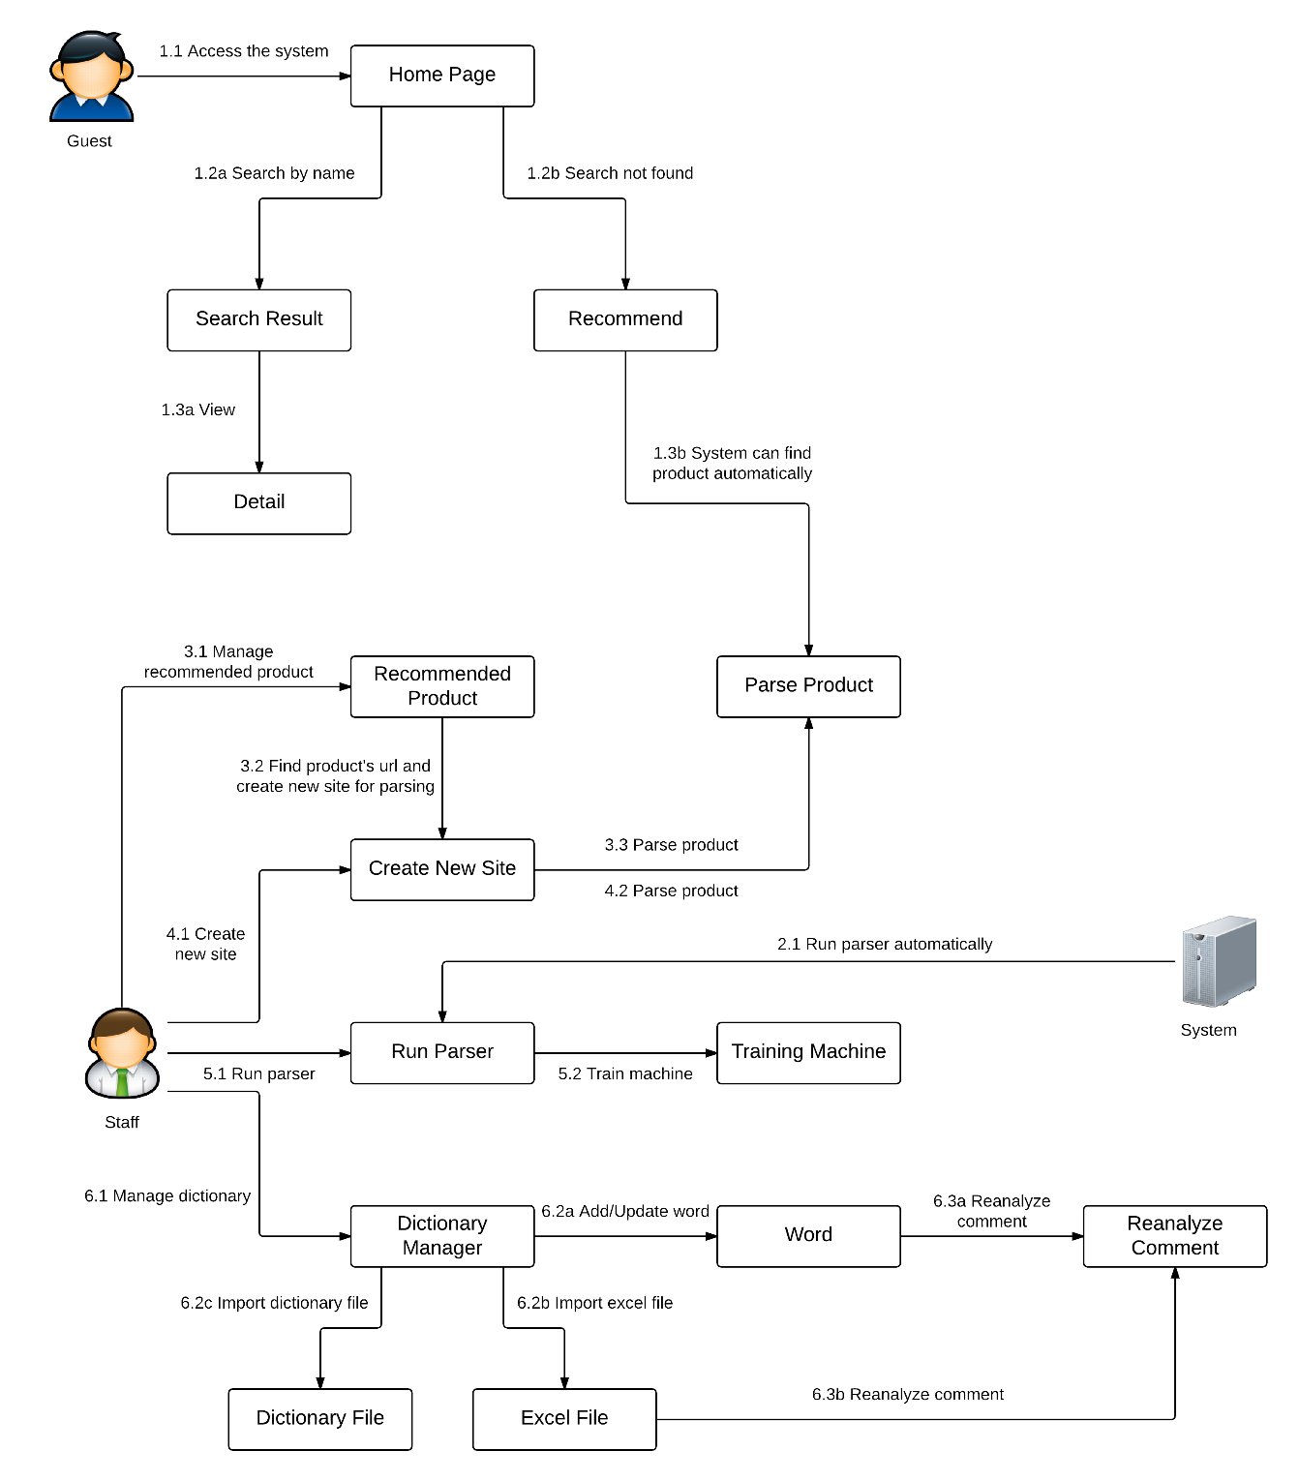

Figure 2 Guest, Staff Core Flow

### Guest Test Case

#### Search Product by name

|  |  |  |  |  |  |  |  |
| --- | --- | --- | --- | --- | --- | --- | --- |
| **ID** | **Test Case Description** | **Test Case Procedure** | **Expected output** | **Inter-test Case Dependence** | **Result** | **Test Date** | **Note** |
| SP01 | Guest searches product by name. | 1 – On the home page, click on “”.  2 – Input name of product on search textbox.  3 – Pressing enter key. | - After step 1, go to search page  - After step 3, show search result with product name, picture, positive percent. |  | Passed | 23/07/2015 |  |
| SP02 | Member searches product by name. | 1 – On the home page, click on “”.  2 – Input name of product on search textbox.  3 - Pressing enter key. | - After step 1, go to search page  - After step 3, show search result with product name, picture, positive percent. |  | Passed | 23/07/2015 |  |

**Table 4: Search Product by name Test Case**

#### Report Comment

|  |  |  |  |  |  |  |  |
| --- | --- | --- | --- | --- | --- | --- | --- |
| **ID** | **Test Case Description** | **Test Case Procedure** | **Expected output** | **Inter-test Case Dependence** | **Result** | **Test Date** | **Note** |
| RC01 | Guest reports comment. | 1 – On the detail page, click on “flag” icon at the beginning of any comment. | - After step 1, the color of this comment is blue. A pop-up with the message notifying new report will be shown in “Staff” page. |  | Passed | 23/07/2015 |  |

**Table 5: Report Comment Test Case**

#### View Product Detail

|  |  |  |  |  |  |  |  |
| --- | --- | --- | --- | --- | --- | --- | --- |
| **ID** | **Test Case Description** | **Test Case Procedure** | **Expected output** | **Inter-test Case Dependence** | **Result** | **Test Date** | **Note** |
| VPD01 | Guest view detail. | 1 – On the search page, click on product name. | - After step 1, go to detail page. |  | Passed | 23/07/2015 |  |
| VPD02 | Member view detail. | 1 – On the search page, click on product name. | - After step 1, go to detail page. |  | Passed | 23/07/2015 |  |

**Table 6: View Detail Test Case**

### Staff Test Case

#### Manage Recommended Product

|  |  |  |  |  |  |  |  |
| --- | --- | --- | --- | --- | --- | --- | --- |
| **ID** | **Test Case Description** | **Test Case Procedure** | **Expected output** | **Inter-test Case Dependence** | **Result** | **Test Date** | **Note** |
| MRP01 | Staff view list of recommended product | 1 – Login into the system using a staff account  2 – On the staff home page, click “Product Management”, and then click “Recommended Product”.  3 – Click name of any product.  4 – Input url of new product in the text box.  5 – Click “Parse product” button.  6 – Click “Yes” button. | - After step 2, a list of recommended product will be shown.  - After step 3, a pop-up with this recommendation will be shown.  - After step 5, if the site which this product belongs to was not existed, a pop-up with a yes/no question will be shown.  - After step 6, the system will redirect to “Create New Site” page with this url will be filled in the “Url of site” text box. |  | Pass | 13/08/2014 |  |
| MRP02 | Create new site and parse recommended product | After step 6 in MRP01:  1 – Click “View” button.  2 – Fill in site’s detail   1. “Name” step 2. “Brand” step 3. “Description” step 4. “Image” step 5. “Date” step 6. “Content” step   3 – Click “Finish” button  4 – Click “Create New Site” button | - After step 1, a wizard form for creating new site with 6 steps will be show.  - After step 3, a pop-up with site’s detail will be shown.  - After step 4, new site will be inserted into database. The system will auto parse this product and inserted it into database. After that, the system will redirect to “Recommended Product” page and the message with the status of parsing product will be shown. | MRP01 | Pass | 13/08/2014 |  |

**Table 7: Manage Parser Test Case**

#### Create New Site

|  |  |  |  |  |  |  |  |
| --- | --- | --- | --- | --- | --- | --- | --- |
| **ID** | **Test Case Description** | **Test Case Procedure** | **Expected output** | **Inter-test Case Dependence** | **Result** | **Test Date** | **Note** |
| CNS01 | Staff creates new site | 1 – Login into the system using a staff account  2 – On the staff home page, click “Parser”, and then click “Create New Site”.  3 – Click “View” button.  4 – Fill in site’s detail   1. “Name” step 2. “Brand” step 3. “Description” step 4. “Image” step 5. “Date” step 6. “Content” step   5 – Click “Finish” button  6 – Click “Create New Site” button | - After step 2, a textbox for inputting url of site will be shown.  - After step 3, a wizard form for creating new site with 6 steps will be show.  - After step 5, a pop-up with site’s detail will be shown.  - After step 6, new site will be inserted into database. |  | Pass | 13/08/2014 |  |
| CNS02 | Staff parse a specific product | 1 – Login into the system using a staff account  2 – On the staff home page, click “Parser”, and then click “Run parser”  3 – Input url to “Product’s url” textbox and click “Parse product”. | - After step 2, the page with 2 tab will be shown and the “Parse specific product” will be selected.  - After step 3, product will be inserted to database and the message with the status of parsing product will be shown. |  | Pass | 13/08/2014 |  |

**Table 8: Create New Site Test Case**

#### Train Machine

|  |  |  |  |  |  |  |  |
| --- | --- | --- | --- | --- | --- | --- | --- |
| **ID** | **Test Case Description** | **Test Case Procedure** | **Expected output** | **Inter-test Case Dependence** | **Result** | **Test Date** | **Note** |
| TM01 | Staff uses training machine function | 1 – Login into the system using a staff account.  2 – On the staff home page, click “Products” on navigation bar, and then click “Training Machine”. | - After step 2, duplicated products list in log file will be shown with related commands | N/A | Pass | 20/07/2015 |  |
| TM02 | Staffs merge products. | After step 2 in test case TM01.  1 – Click checkbox to selected duplicated products  2 – Select “Main” product by clicking “Main” radio button.  3 – Click “Merge” button | - After step 3, system will check whether main product belongs to selected products in step 1:  + If main product belongs, selected duplicated products are added into database.  + Else, return a pop-up requires staffs to choose appropriate main product. | TM01 | Pass | 20/07/2015 |  |
| TM03 | Staffs split products. | After step 2 in test case TM01.  1 – Click checkbox to selected duplicated products.  2 – Click “Split” button. | - After step 2, system will check whether staffs have selected any products or not in step 1:  If yes, duplicated products will be split and saved into database.  Else, return a pop-up requires staffs to choose at least 1 product to process. | TM01 | Pass | 20/07/2015 |  |
| TM04 | Staffs disable products | After step 2 in test case TM01.  1 – Click “Disable” button of each duplicated product | - After step 1, the product which disable button is clicked will be disabled and disappeared from the list. | TM01 | Pass | 20/07/2015 |  |
| TM05 | Staffs enable products | After step 1 in test case TM04.  1 – Click “View disabled duplicated products”  2 – Click “Enable” button of each disabled products | - After step 1, the list of disabled products is shown with related command.  - After step 2, disabled product is enabled. | TM04 | Pass | 20/07/2015 |  |
| TM06 | Staffs search duplicated products | After step 2 in test case TM01  1 – Input search string into “Input text search” textbox | - After step 1, appropriate products are shown | TM01 | Pass | 20/07/2015 |  |
| TM07 | Staffs view log file | After step 2 in test case TM01.  1 – Staff choose “Show log file” in navigation bar | After step 1, a list of managed products are shown with following information:  - Main Product Image  - Product name  - Action Type (Merge or Split)  - Updated Date | TM01 | Pass | 20/07/2015 |  |

#### Update Word

|  |  |  |  |  |  |  |  |
| --- | --- | --- | --- | --- | --- | --- | --- |
| **ID** | **Test Case Description** | **Test Case Procedure** | **Expected output** | **Inter-test Case Dependence** | **Result** | **Test Date** | **Note** |
| UW01 | Staffs use Dictionary Management function | 1 – Login into the system using a staff account.  2 – On the staff home page, click “Dictionary” on navigation bar, and then click “Dictionary Management”. | - After step 2, dictionary words will be shown with first word in the list’s meaning | N/A | Pass | 23/7/2015 |  |
| UW02 | Staffs view word’s definition | After step 2 in UW01.  1 – Staffs click on word in the word list | - After step 1, word’s definition is shown | UW01 | Pass | 23/7/2015 |  |
| UW03 | Staffs update word | After step 1 in UW03.  1 – Staff click “Update word”  2 – Edit form appears, staffs can update:  - Class  - Type  - Synonyms  - Antonyms  3 – Staff click “Save” | - After step 3, Updated information is saved to database | UW03 | Pass | 23/7/2015 |  |
| UW04 | Staffs add word | After step 2 in UW01.  1 – Staff click “Add New” on navigation bar  2 – Staffs input new word information includes:  - Word  - Class  - Type  - Synonyms  - Antonyms  3 – Staffs click “Add new word” | - After step 2, system will check whether staffs have inputted Word field:  + If yes, staff can process step 3 and new word is added to database  + Else, “Save” button is disabled | UW01 | Pass | 23/7/2015 |  |
| UW05 | Staffs search for specific word | After step 2 in UW01.  1 – Staffs input search string into Search text box | - After step 2, list word will automatically filters words base on staffs input | UW01 | Pass | 23/7/2015 |  |
| UW06 | Staffs re-analyse comment | After step 2 in UW01.  1 – Staffs click “Re-analyze comments” button | - After step 1, comments will be re-analyzed. System will check whether comments are re-analyzed successfully or not:  + If yes, a pop-up appears to indicate process is successfully done  + Else, a pop-up appears to show error message | UW01 | Pass | 23/7/2015 |  |